


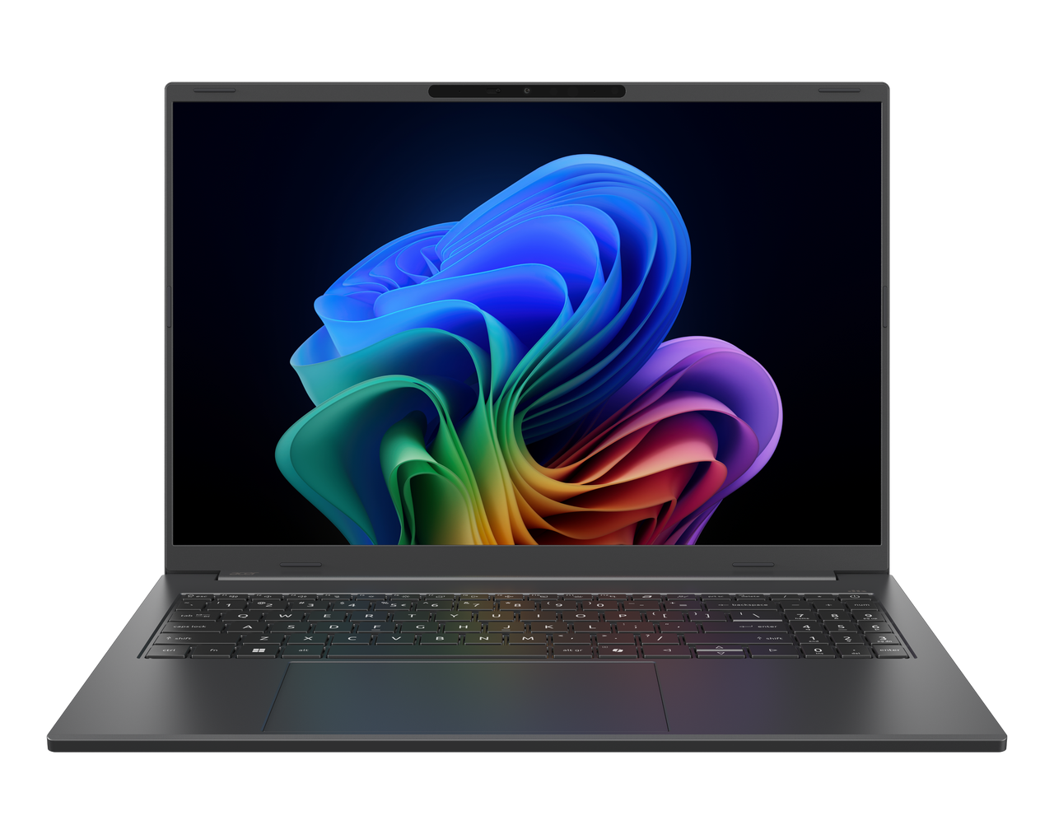

Aspire 16 AI

SPECIFICATIONS Aspire 16 AI A16-I71M | A16-I71MT
Acer NITRO V 16S ANV16S-71
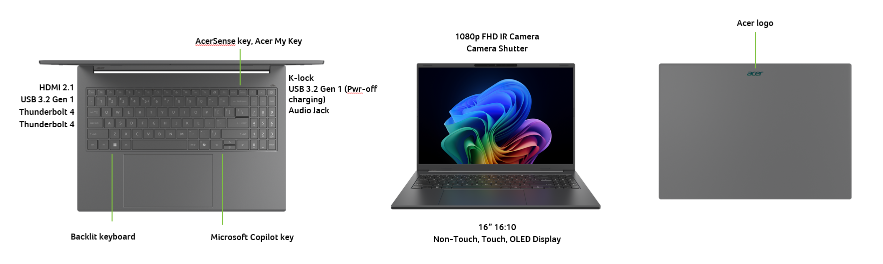
Operating System |  | Windows 11 Home
CPU and Chipset |  | Intel® Core™ Ultra 5 processor 322  Intel® Core™ Ultra 5 processor 325 | Intel® Core™ Ultra 5 processor 355  Intel® Core™ Ultra 5 processor 386H
Memory |  | Up to 16/32 GB of Dual-channel LPDDR5X SDRAM support | Memory Frequency: Up to 5600 MT/s
Display |  | A16-I71MT  16.0" display with IPS (In-Plane Switching) technology | WUXGA 1920 x 1200 | LED-backlit LCD | Integrated multi-touch  •16:10 aspect ratio  •100% sRGB color gamut  •Super-slim design  •Mercury free, environment friendly |  | A16-I71M  16.0" display with OLED (Organic Light-Emitting Diode) technology | WUXGA 1920 x 1200 | 300 nits brightness, typical | Acer CineCrystal™  •16:10 aspect ratio  •100% DCI-P3 color gamut, typical  •Wide viewing angle up to 170 degrees  •Mercury free, environment friendly |  |  | A16-I71M  16.0" display with IPS (In-Plane Switching) technology | WUXGA 1920 x 12060 | Acer ComfyView™ LED-backlit TFT LCD | 120 Hz refresh rate  •16:10 aspect ratio  •100% sRGB color gamut  •Wide viewing angle up to 170 degrees  •Mercury free, environment friendly |  | A16-I71M  16.0" display with IPS (In-Plane Switching) technology | WUXGA 1920 x 1200 | Acer ComfyView™ LED-backlit TFT LCD | 120 Hz refresh rate  •16:10 aspect ratio  •45% NTSC color gamut  •Wide viewing angle up to 170 degrees  •Mercury free, environment friendly
Graphics |  | Intel® Graphics eligible  Graphics Special Technology: AVC, HEVC, VP9, AV1, VVC HW Accelerated Video Decode AVC, HEVC, AV1 HW Accelerated Video Encode  Microsoft DirectX 12  ​OpenGL 4.6  OpenCL 3.0
Audio |  | DTS® Audio, featuring optimized bass response and micro-speaker distortion prevention  Acer TrueHarmony Technology for lower distortion, wider frequency range, headphone-like audio and powerful sound by Acer Ultra Boost Stereo Speaker Module  Compatible with Cortana with Voice |  |  | Acer Purified.Voice technology with AI noise reduction with dual-mic array built-in microphones. Features include far-field pickup, dynamic noise reduction through neural network, adaptive beam forming, and pre-defined personal and conference call modes.  High SNR DAC with 2.1 Vrms out capability and can driver high impedance headphone (up to 600 ohm)
Storage |  | Solid state drive: 512 GB / 1 TB, PCIe Gen4, 16 Gb/s, NVMe
Webcam |  | Windows configuration  UFC with USB FHD camera | 1920 x 1080 resolution | Dual microphones | Windows compatible
Wireless and Networking |  | WLAN:  Intel® Wireless Wi-Fi 6E AX211  802.11 a/b/g/n/ac/ax wireless LAN  Band: 2.4 GHz, 5 GHz, and 6 GHz  2x2 MU-MIMO technology  Intel® Connectivity Performance Suite (ICPS) | WPAN:  Supports Bluetooth® 5.3 or above
Security |  | Microsoft Pluton security processor | Firmware TPM solution | Camera shutter | Kensington lock slot
Dimensions and Weight |  | Dimensions  354.9 (W) x 250.1 (D) x 15.9/15.9 (H) mm (13.97 x 9.85 x 0.63/0.63 inches) |  |  | Weight  1.52 kg (3.35 lbs.) with 3-cell battery pack
Power Adapter and Battery |  | Power Adapter  3-pin 100 W PD PCR 50%, TCO 9.0 AC adapter  •5 V / 3 A or 9 V / 3 A or 12 V / 3 A or 15 V / 3 A or 20 V / 3.25 A as output power  •108.0 (W) x 56.0 (D) x 26.5 (H) mm (4.25 x •2.20 x 1.04 inches)  •296 g ± 5% with 150 cm DC cable  •Black color with Acer logo  •Brick type AC pins | USB Type-C 65 W PD PCR 50%, TCO 9.0 AC adapter  •5 V / 3 A or 9 V / 3 A or 12 V / 3 A or 15 V / 3 A or 20 V / 3.25 A as output power  •90.0 (W) x 51.0 (D) x 28.5 (H) mm (3.54 x 2.01 x 1.12 inches)  ​•192 g ± 10% with 150 cm DC cable  •Black color with Acer logo  •Brick type AC pins
Input and Control |  | 99 / 100 / 103 keys | Acer backlit keyboard layout | Numeric keypad | International language support | SR05P  •Slim design | 1.3 mm key travel  •Dedicated AcerSense key  •Programmable key | My Key  •Enlarged keycaps  •Adjustable backlight brightness  •Quiet design for noise reduction  •Caps Lock indicator  •Microphone mute indicator  •Function Lock key |  |  |  | Touchpad  Multi-gesture touchpad | Two-finger scroll | Pinch gesture | Gestures to open Cortana | Action Center | Multitasking | Application commands  Microsoft Precision Touchpad certification  Moisture resistant |  | Control keys  Programmable key | My Key  AcerSense key  Microsoft Copilot key
Windows Desktop Apps |  | In-House Applications  In-house | Acer AI Image Generator | Acer LiveArt | Acer ORD Service | Acer QuickPanel | Acer VisionArt |  |  | Tools  Acer My Key Application
Warranty |  | One-year International Travelers Warranty (ITW)
Disclaimers
• | Specifications vary depending on model.
• | Shared system memory may be allocated to support graphics, depending on system memory size and other factors. Actual system memory available to the operating system will be reduced by any memory used by the graphics solution and resources required by the operating environment.
• | Memory speed may vary, depending on the CPU, chipset or memory fitted.
• | All brands and product names mentioned herein include trademarks of their respective companies and are used solely to describe or identify the products.
• | Not all features indicated are supported on all SKUs
• | 1 GB is 1 billion bytes. Actual formatted capacity is less and may vary depending on preloaded materials and operating environment. Acer Recovery Management uses a portion of the stated hard disk capacity as dedicated backup space.
• | Minor variations in system dimensions are possible due to the manufacturing process.
• | Weight may vary depending on product configuration, vendor components, manufacturing variability, and selected options.
• | Bundled software may vary depending on hardware configuration, OS and regional availability.
Product Sheet is based on Aspire A16-I71M Specifications (v1-0-0) (Preview) and Aspire A16-I71MT Specifications (v1-0-0) (Preview)
In a continuing effort to improve the quality of our products, information in this document is subject to change without notice. Images shown are only representations of some of the configurations available for this model. Availability may vary depending on region. As a phenomenon known to thin-film transistors (TFTs), liquid crystal displays (LCDs) commonly exhibit a small number of discoloration dots, as so-called "non-conforming pixels." This phenomenon is a limitation of TFT LCD technology, not a product defect, and as such is not covered by Acer's warranty.
© 2026. All rights reserved.
Microsoft and Windows are registered trademarks of Microsoft Corporation.
3D XPoint, Agilex, Altera, Arc, Arria, Avalon, Axxia, Barefoot Networks, the Barefoot logo, the Footsie logo, Celeron, Cyclone, Docae, DoubleShot, eASIC, easicopy, FlexRAN, Gaudi, Granulate, HyperFlex, Intel, the Intel logo, Intel Adapix, Intel Agilex, Intel Atom, Intel Cofluent, Intel Core, Intel Evo, Intel Geti, Intel Inside, the Intel Inside logo, Intel Optane, Intel RealSense, Intel SpeedStep, Intel Tiber, Intel Unison, Intel vPro, Iris, Killer, Linux, MAX, Movidius, Myriad, Nios, OmniBridge, OpenVINO, the OpenVINO logo, Pentium, Quartus, Simics, SmartByte, SoFiaSilicon, Sound Mark, StarPro, Stay With It, the Engineering Stay With It logo, Stratix, the Stratix logo, the Journey Inside, Thunderbolt, the Thunderbolt logo, Tofino, Ultrabook, VTune, and Xeon are trademarks of Intel Corporation or its subsidiaries.
About Acer
Founded in 1976, Acer is one of the world's top ICT companies with a presence in more than 160 countries. As Acer evolves with the industry and changing lifestyles, it is focused on enabling a world where hardware, software and services will fuse with one another, creating ecosystems and opening up new possibilities for consumers and businesses alike. Acer's 7,500 employees are dedicated to the research, design, marketing, sale, and support of products and solutions that break barriers between people and technology. Please visit www.acer.com for more information.

